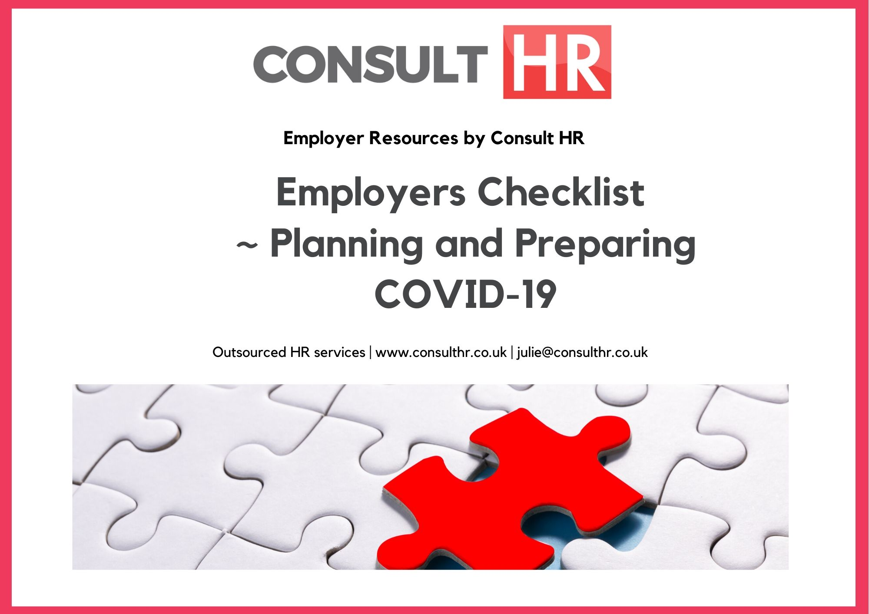
COVID-19 Return to Work Form

To help prevent the spread of COVID-19 in the workplace, every worker must complete and sign this form before returning to work. On review of the form, management may contact you and ask you not to return to work immediately and will discuss a suitable future date for your return. N.B. Every question must be answered.

Employee Name: |  | Manager Name:
Workplace Address:
Question |  |  | Yes |  | No
1. | Do you have symptoms of cough, fever, high temperature, sore throat, runny nose, breathlessness or flu like symptoms now or in the past 14 days?
2. | Have you been diagnosed with confirmed or suspected COVID-19 infection in the last 14 days?
3. | Are you a close contact of a person who is a confirmed or suspected case of COVID-19 in the past 14 days (i.e. less than 2 metres for more than 15 minutes altogether in 1 day)?
4. | Have you been advised by a doctor to self-isolate at this time?
5. | Have you been advised by a doctor to ‘Shield’ at this time?
6. | Please provide details* below of any other circumstances relating to COVID-19, not included in the above, which may need to be considered to allow your safe return to work. Further guidance can be found on this link - https://www.gov.uk/government/publications/guidance-on-shielding-and-protecting-extremely-vulnerable-persons-from-covid-19/guidance-on-shielding-and-protecting-extremely-vulnerable-persons-from-covid-19#parents-and-schools-with-clinically-extremely-vulner
Additional Information

* If you are unsure whether or not you are in an at-risk category, please check the information at the link in Question 6. If your situation changes after you complete and submit this form, please tell management.
Print Name: Signature: Date:

Page 1 of 1

